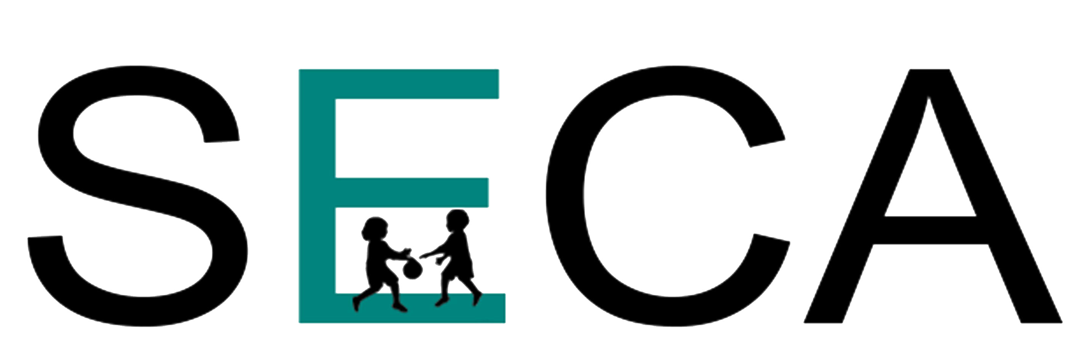

SECA Student Grant Program

The Southern Early Childhood Association is offering a matching grant program to student groups to assist in attendance at the Annual SECA conference. These grants will be available to the following groups:

Technical/community college or university student groups (A group may
consist of students from several different classes/campuses that are under the sponsorship of one college or university.)

Student affiliates or chapters that are recognized by the SECA or NAEYC state affiliate.

High school student groups.

Amount of matching grant: Maximum of $1000. per group.
Grants smaller than $1000 will be made, depending upon the amount requested by the student group and the matching funds available. Grants will be made on a first-come, first-served basis.

Matching Funds: Groups must certify that they have raised funds that correspond on a one-to-one basis with any grant funds released by SECA. For example, if the student group raises $500, SECA will match that amount with a $500 grant. Certification of matching funds must be made by verification of funds available in a student bank account. (This certification can be provided by the bank or by the financial officer of a school, college or university. The group must have a bank account that is identified as belonging to the group.)

Letter of Intent: A group that is interested in applying for matching funds should send a letter of intent (including the amount of matching funds requested) to:

E-mail:
Maurena Lopez at mlopez@seca.info. The subject line of the e-mail should read “Student Grant Letter of Intent”. Attach the Letter of Intent (on letterhead and signed) to the e-mail.

These letters of intent will be accepted as initial applications for the grant funds and funds will be reserved to fund the final applications. The letter of intent must be sent on university, college or school letterhead and be signed by a faculty member. Letters of Intent will be accepted until December 2, the year prior to the conference (i.e. December 2, 2023 for 2024 conference).

Definition of Student Group: A group must be comprised of at least 5 students to be eligible for the maximum award. Groups of fewer than 5 students will be considered eligible for a reduced grant award. An eligible group will consist of no fewer than 3 students.

Certification of Student Groups: SECA will contact the President of the appropriate state affiliate to ask that they certify that the group that has applied is a legitimate student group in that state. Student groups are not required to be a formally recognized state affiliate/chapter group; however, the state affiliate President must be able to verify that this group has formed for the purpose of furthering the development of early childhood professionals and is made up to students who are studying early childhood education. When that certification is received, the letter of intent is considered approved.

Conference Registration: Conference registration must be submitted and paid for each student attending the conference. The SECA office will verify that members of the group have submitted registrations. Groups that do not register students will be subject to recovery of grant funds.

Transportation and Housing: The Student Group must arrange transportation and housing, and SECA assumes no liability for transportation. Housing will be available to the group under the negotiated SECA conference rate if booked prior to the hotel cut-off date.

Notice of Receipt of Letter of Intent: The SECA office will send verification that the Letter of Intent has been received and the group is eligible for matching funds.

Final Application for Matching Funds: The attached form must be completed and returned to the SECA office no later than January 2, of the same conference year (i.e. January 2, 2024 for the 2024 conference). If the final application is not received by January 2, matching funds may not be available to the applicant group. Funds will be released to approved groups by January 22 of the same conference year.

FINAL APPLICATION

SECA STUDENT MATCHING FUNDS PROGRAM

Name of University/College/School________________________________________

Address______________________________________________________________

City___________________________State______________Zip__________________

Phone____________________________Fax_________________________________

Person Submitting Application____________________________________________

E-mail Address________________________________________________________

Name of Student Group__________________________________________________

# of Students in Group______ # of Students Attending SECA Conference_______

Faculty Advisors ______________________________________________________

Advisors Accompanying Group to Conference_______________________________

Type of Fundraiser/s______________________________________________________

Date/s of Fundraiser____________________ Total Amount Raised_______________

Method of Transportation_______________________________________________

Funds Requested from SECA________________________________________

Check should be issued to: _____________________________________________

Address to which check should be sent:____________________________________

___________________________________________________________________
Checks will be issued to the school or group. No checks to individuals will be issued.
Certification of Matching Funds (Attach to application)

 Current bank statement of student group that reflects adequate funds to match
funds requested from SECA, OR
 Letter of certification (on letterhead) signed by appropriate financial officer.
Letter should contain amount of student funds raised or available
to match SECA funds.

E-mail to:
mlopez@seca.info

